**Connecting GaAsP PMT to RJ11 connector.**

The Hamamatsu H7422P-40MOD or H10770PB-40 SEL GaAsP PMTs terminate with bare wires. Connect the 4 power and control wires to a 4-6 (6 positions, 4 connectors, aka “RJ11”) modular plug a short distance from PMT. Attach a short piece of the appropriate 4 conductor cable to the connector with a crimper first, and then solder wires to wires.

Pinout:

|  |  |  |
| --- | --- | --- |
| PMT wire | PMT wire color | Connector pin |
| Vcc, +15V | Red | 4 |
| GND | Black | 3 |
| Vref | Blue | 2 |
| Vcontrol | white | 1 |

Modular 6-4 (RJ11) connector pin assignment.

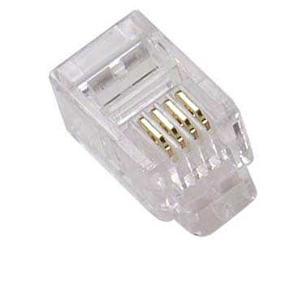

Pin 1